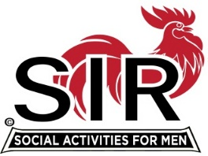

Las Trampas Branch 116
Luncheon Meeting Agenda
Aug 23rd, 2022, 10:30 AM

10:30 Check-in
Greeters at the door – Paul Ramacciotti, Alan Pope
Vaccination Check – Kevin Donahue
Treasurer Table – Alan Fitzgerald, Al Satake
Name Tags Table – Mike Schneider
Raffle Table – Tom Eller, Bob Donohue

11:25 Five Minute Call
11:30 Call to order; Welcome back to all – Big SIR
Pledge of Allegiance – Fred Schafer
Chaplain – Darrell McClaughry
Sunshine Report – Matt Arena

11:40 Story Teller – Fred Schafer
11:45 2023 BEC Nominations and Vote - Sam Beret
Special Guests: - Terry McGill hosted by Chuck Vanoncini, Jim Briggs hosted by Don Schroeder
Other Branch Updates – Fred Wachowicz, Roger Craig

11:45 Salad Served
12:00 Lunch
12:10 Activity Committee Announcements - Jeff Johnson and Mike Ward
12:20 Introduce Speaker, Mr. Ben Lavender – Paul Freitas
13:05 Speaker Thank You, Little SIR - Roger Craig
13:10 Raffle Drawing – Tom Eller, Bob Donohue
Birthday Drawing– Little SIR - Roger Craig
13:20 Sing Happy Birthday – Music - Paul King
Sing God Bless America - Paul King

13:25 Closing Remarks – Big SIR
13:30 Adjourn; Next Meeting, Sept 19th
************************************************

